Water Conservation Poster Contest
Port St. Lucie Utility Systems cordially invites students to participate in our "Drop Savers" poster contest. Students in grades K-12 are encouraged to create a poster depicting a water conservation idea, in slogan form, drawing form, or both. The contest teaches elementary-aged school children, and reminds middle and high school-aged teens, about the importance of water conservation. We feel that our best opportunity to conserve water is through a long-range education and awareness program, and what better way than to begin with our young people!

Poster Contest Guidelines
Posters will be designated under one of the following categories:
Division 1: Kindergarten and First Grade
Division 2: Second and Third Grade
Division 3: Fourth and Fifth Grade
Division 4: Middle School; Grades Six, Seven and Eight
Division 5: High School; Grades Nine, Ten, Eleven and Twelve

- Poster shall be drawn on an 8 ½” x 11” sheet of paper. It could be drawn vertically or horizontally.
- Each poster must portray a Water Conservation Idea in a slogan, drawing, or both. Students may use crayons, paint, color pencils, or markers. No highlighters, photos, or computer graphics are permitted.
- Students must work on posters individually, otherwise posters will be disqualified.
- Only original artwork will be accepted (no trade-marked or copyrighted materials).
- Entry form must be taped to the back of each poster

Judging
- A panel of judges from the City of Port St. Lucie will rate the posters for the message, creativity, and originality (not just artistic ability).
- Judges will choose a first place winner from each grade division.
- Remember that students are to create a poster depicting a Water Conservation idea! "Don't Pollute the Water" is a good theme, but is not really water conservation.

Prizes
- Be recognized at a City Council Meeting
- Be featured on the City’s website and social media handles
- Display of artwork in City Hall and Utility Systems facilities
- Gift Cards

Winners will have an opportunity to participate in the FSAWWA statewide
Drop Savers poster contest and obtain additional prices. For more information, visit: http://fsawwa.org.
DEADLINE for entries is FEBRUARY 24, 2017

WATER CONSERVATION POSTER CONTEST ENTRY FORM
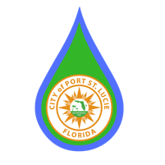
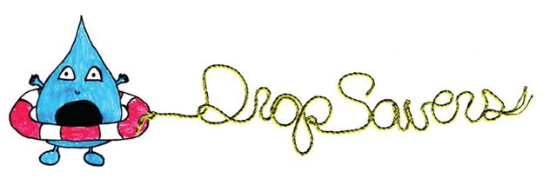
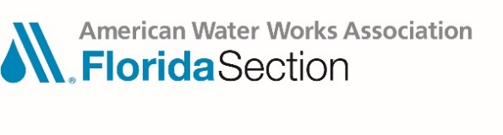

Utility Name: Port St. Lucie Utility Systems
Coordinator Name: Jenny Tomes
Utility Phone #: (772) 871-5131
Utility email: jtomes@cityofpsl.com
SCHOOLS ARE ASKED TO PLEASE CONTACT JENNY TOMES TO PICK UP THE POSTER ENTRIES ON OR BEFORE FEBRUARY 24, 2017.

Student’s Name: __________________________ ____________________ ___

Student’s Grade: _________________________________________________

Student’s School: ________________________________________________

Teacher’s Name: _________________________________________________

